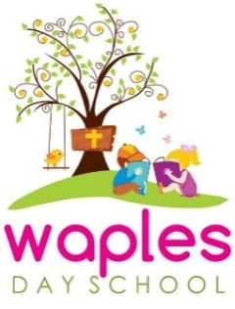
Registration for 2026-27 School Year
Registration will not be accepted until both completed application and registration fees are turned in. Please note that Annual Registration/Building Fees are non-refundable.

Early Registration Fee Discount (limited time)-open to current students/siblings/church members
(Jan 20-Feb 8)-$175.00 ($125.00 plus $50.00 Building Fee)
Early Registration Fee- enrollment open to the public
(Feb 9-May 13)-$200.00 ($150.00 plus $50.00 Building Fee)
Registration Fee-general
(May 14 and on)-$225.00 ($175.00 plus $50.00 Building Fee)
**Church member registration fee is discounted to $125.00**

Waples Day School Tuition
2026-27 School Year
*First tuition payment is due August 15, second is due Sept 1*

3 Days/Week (2 & 3 year olds-must be potty trained)
AM Program (8:30-11:30)-$2520/year
($280/month for Sept-April. Aug and May are ½ month tuition)
Extended Day (8:30-2:30)-$3600/year
($400/month for Sept-April. Aug and May are ½ month tuition)
5 Days/Week (3 & 4 year olds-must be potty trained)
AM Program (8:30-11:30)-$3195/year
($355/month for Sept-April. Aug and May are ½ month tuition)
Extended Day (8:30-2:30)-$4590/year
($510/month for Sept-April. Aug and May are ½ month tuition)

**There is a $25/month discount for each additional sibling enrolled.

